1. Using MySQL Shell to create a database called “LabDb”.

2. Then create two tables, one called “User”, another one called “Product”. Table structures should looks like the design below. Both ID should defined as auto_increment data type.

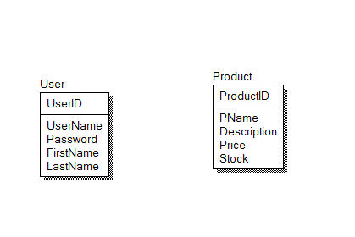

3. Using XAMPP phpMyAdmin to add ten rows for each table.

4. Create a PHP page that query the product table and return/display all data from the table.

5. Create a simple form that accepts user name, password, first name, and last name. Get your form to call a PHP page which will add the user input into the user table.